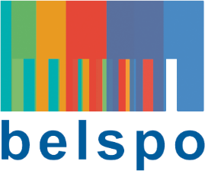

FEDERAL SCIENCE POLICY

RESEARCH PROGRAMME FOR EARTH OBSERVATION STEREO III
(Support to Exploitation and Research in Earth Observation)

call for proposals 2016 - Thematic network projects

Expression of interest

Closing date: 28 January 2016 at 5 PM

Mandatory for the submission of a research proposal
Please send to SRIII@belspo.be

Coordinator :
Name: (name, first name)
E-mail:
Tel:
Institution (acronym):
Department:
URL:

PROJECT INFORMATION:
Budget estimate (in €):
Estimated duration:
Research theme (more than one is possible):
Global monitoring of vegetation and evolution of terrestrial ecosystems
Management of the local and regional environment
Interaction between (change in) land cover and climate change
Epidemiology and humanitarian aid
Security and risk management
Project title (maximum 12 words) :
Short description (rationale, objectives, methodology,…) (15 lines)
Acronym:
Keywords:
Test site(s):

REFERENCES:
Five recent key publications by the applicant(s) in the field of the proposal:
Five recent external key publications in the field of the proposal:

Project partners:
Name + Organisation + URL | Core expertise
 | Remote sensing | Other: specify
International partner:
Partner search (profile, expertise, ...):

If your partnership is not yet complete, we can suggest you researchers that may fit your requirements

