China-Belgium Call for Proposals 2015

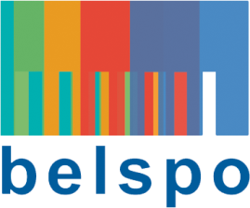
Check list "CLIMocean call"

Eligibility of Proposals for Belgian partners

Please check at the submission of your proposal if it fulfills all the eligibility criteria; BELSPO's evaluation process starts with the check of the list. The coordinators from whom the proposal(s) are not eligible are informed by BELSPO.
The eligibility of proposals is evaluated on the basis of the information given by the submittors in the submission dossier.

List of criteria
Each proposal is checked (up)on the following criteria. Only proposals fulfulling ALL criteria are evaluated.

- The submission dossier is received at latest on.22 March 2016, at 15h
- The submission dossier is transmitted at Belgian side (BELSPO) and at the Chinese side(MOST), signed by both coordinators
- The network consists of participants from universities and/or public scientific institutions, and/or non-profit research centers
- The part of the submission dossier adressed to BELSPO includes the two requested correctly filled in forms (form in English + the form regarding the budget)
- The submission dossier is provided by electronic version (in Word en in Pdf)
- The proposal concerns a researchproject with at least 2 Chinese and 2 Belgian partners
- In case that an optional European partner participates in the project, the letter mentionning the funding by a funding source different from MOST or BELSPO is to be included in the submission dossier
- The proposal complies with the rules written in the rubrique 'budget' of the submission dossier
- The demanded BELSPO budget contribution does not exceed 250.000 EUR
- De duration of the proposed project is maximum 3 years

A proof of reception is send.
The form in Dutch or French concerning the budget is destinated only to BELSPO.

