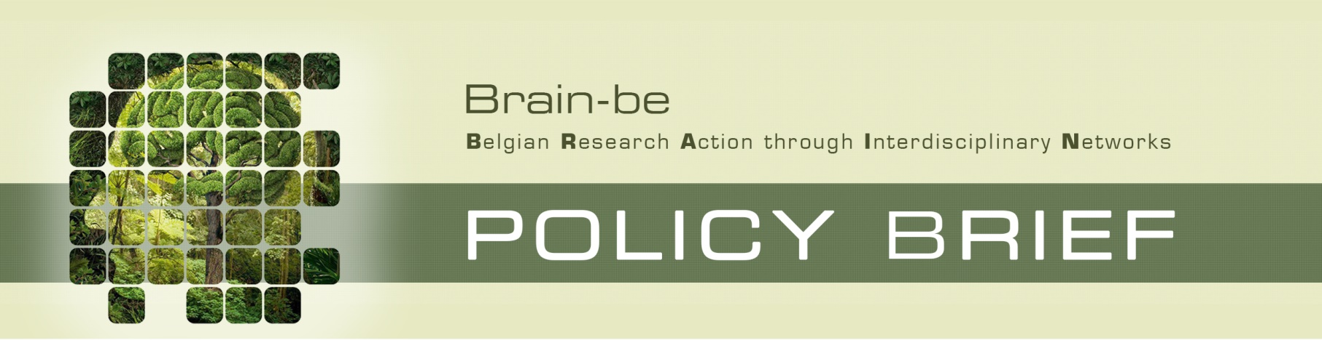
 | Policy Brief n° [***]
 | [Title]
 | [Executive Summary]
 | Context and question(s) of research | BRAIN-be  The research is funded under the BRAIN-be program of the Federal Science Policy (BELSPO).  BRAIN-BE is a multiannual research framework program launched by BELSPO in 2012 which strengthens the scientific base for policy making and reinforces the strategy and potential of the Federal Scientific Institutions (FSI).  BRAIN-be supports single partner and network projects with a duration of 2 or 4 years. Project selection is based on scientific excellence and the fulfillment of national and international research priorities as well as Federal policy needs.  BRAIN-be covers a wide spectrum of thematics going from sciences systems over cultural heritage, through a number of societal challenges.
 | [Text]
 | Main findings
 | [Text]

[Main findings continued]

Conclusion and recommendations
[Text]

Read more
[Text]

Gegevens
Contact
Name, First name:
Institution/Departement:
e-mail:

