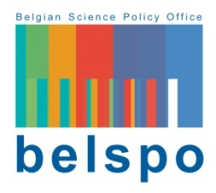

FEDERAL RESEARCH PROGRAMME

DRUGS

Call for proposals 2018

Mark of interest

Closing date: 4 June 2018 - 3 PM

To be sent by email with subject "Topic [X]_[Acronym of the proposal]" and renamed in the format "[Acronym of the proposal]_[name of the coordinator]_[institution of the coordinator].docx" to drugs_call@belspo.be

Mandatory for the submission of a research proposal

Proposal’s acronym (maximum 15 characters):

Research topics:

1. | The role of perceptions, social representations and new communications technologies in understanding the drug problem | ☐
2. | Open scientific contributions to the drug situation in Belgium | ☐

Proposal’s title (maximum 12 words):

Proposal’s acronym (maximum 15 characters):

Name of the coordinator:
Institution:
Department:
Email:

Possible partners (name and institution):

Short description of the research proposal (domain, objectives, methodology,…):
(maximum 2 pages)

Potential foreign experts for the evaluation, covering as many aspects of the proposal as possible (name, institution, expertise and motivation of the choice; max 5)

